5.NF.4 | 5.NF.4
Haley babysits after school 5 days a week Monday through Friday. She earns $9 for each hour she babysits. Haley babysits for 2 hours each day on Monday, Tuesday, and Wednesday. She babysits for 2 ½ hours each day on Thursday and Friday. Haley saves 2/3 of the money she earns each week.  - How much money will Haley save from babysitting in one week?  - Show your work.  - Include the equation or equations used to solve the problem. | A piece of paper is in the shape of a rectangle. The piece of paper is 1 5/8 inches (in.) wide and 8 ¾ in. long.  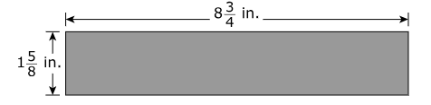  A student cuts the piece of paper in the following order:  - The student cuts off ¾ inch from the width.  - The student cuts off ¾ inch from the length.  - The student cuts the remaining piece of paper into 12 equally long pieces of paper.  What is the area of each of the 12 equally long pieces of paper? Explain your answer completely and show all your work. Include in your explanation an equation you can use to find the area of each of the 12 equally long pieces of paper.
5.NF.5 | 5.NF.6
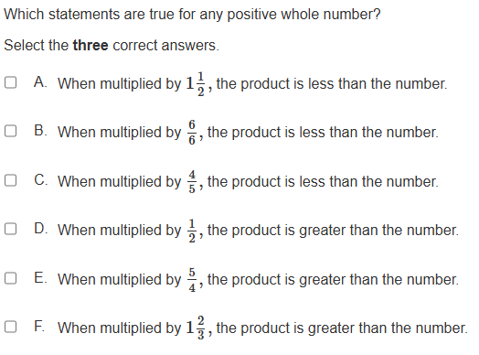 | 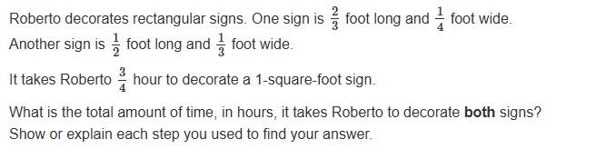
5.NF.7b | 5.NF.7c
Mr. Diaz bought a board that was 12 feet long. He cut the entire board into pieces that were each 1/3 foot long. How many pieces did Mr. Diaz have? | A 1/2-pound bag of granola will be shared equally among 8 friends. How many pounds of granola will each friend receive?
5.NF.3 | 5.NF.5
A 28-inch ribbon is cut into 8 pieces that are all the same length. What is the length of each piece? | 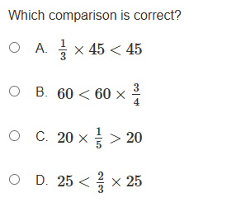
5.NF.7a | 5.NF.7b
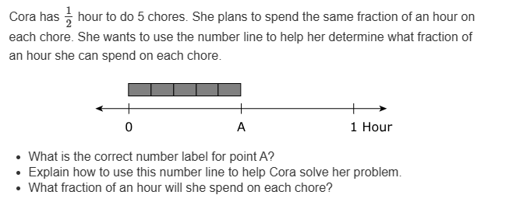 | 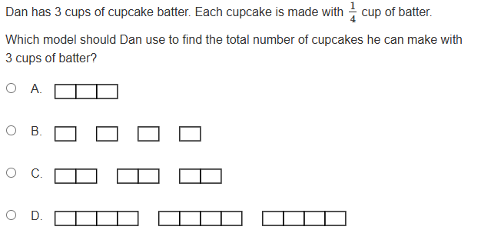
5.NF.4 | 5.NF.4
Part A: The number line shown can be used to find the product of 3/5 and 4.  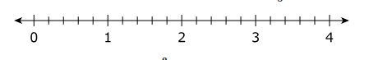  - What is the value of the product of 3/5 and 4?  - Explain how the number line can be used to find the product.  Part B: Explain how a number line can be used to find the product of 3/5 and ½. | Which model represents the multiplication problem  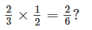  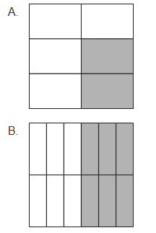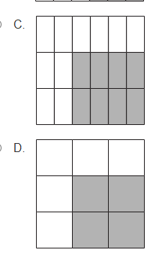
5.NF.6 | 5.NF.3
Dana is making bean soup. The recipe she has makes 10 servings and uses 3/4 of a pound of beans. How many total pounds of beans does she need to make 5 servings of soup?  She has 1/16 of a pound of beans in one container and 1/4 of a pound of beans in another container. How many more pounds of beans does Dana need to make the 5 servings of soup? Show your work or explain your answer. | Kerry cut an 8-foot-long board into 6 pieces that are equal in length. Write this as a fraction. Explain how you can use multiplication to prove that your answer is correct. Include an equation in your explanation.
5.NF.7c | 5.NF.5
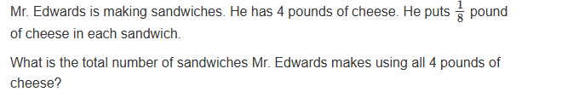 | 