- Jacob Building a Porch
Part A: The length and width of the rectangular porch Jacob built are shown.
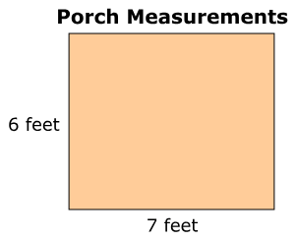
What is the area of the porch?
Part B: Jacob adds another part to the porch.
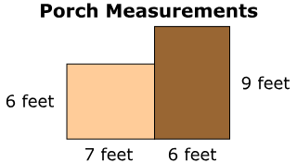
What is the area, in square feet, of both parts of the porch all together? Show all your work or explain how you figured out the total area of the porch. Enter your answer and your work or explanation in the space provided.
- The shape shown below was created by combining two rectangles. What is the perimeter, in feet, of the shape? What is the area, in square feet, of the shape?
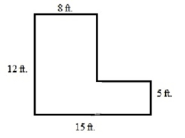

- Area
Part A Figure H is made using equal-sized square units.
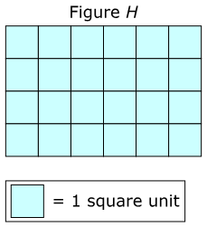
What is the area, in square units, of Figure H?

Part B
Figure Y and Figure Z are each made using equal-sized square units.
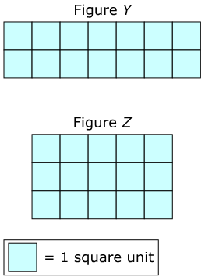

- Explain why Figure Y and Figure Z do or do not have the same area.
- Explain what must be true for any two figures to have the same area.

- The carpet in the Hawkins’ living room has a length of 7 feet. The width is 2 feet more than the length. The family wants to put tile walkways on two sides of the carpet, with lengths and widths as shown.
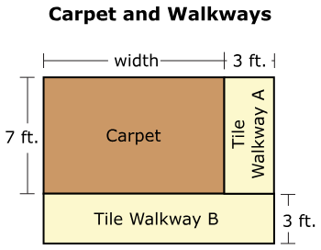

• What is the area of the carpet? Show your work.
• What is the area of each of the tile walkways? Show your work.
• What is the total area of the carpet and the tile walkways? Show your

- Meridith is covering her kitchen with square tiles. She will buy packages of square tiles. Each package contains 8 tiles of the same size. The figure shows the side lengths of the board and one of the tiles.
What is the least number of tiles Meridith needs to cover the floor?
What is the least number of packages of tiles should Meridith buy?
Show your work and explain how you found your answer.
