6.NS.6c | 6.NS.5
The graph shows the location of point P. The x-coordinate of point Q is equal to the opposite of the x-coordinate of point P. The y-coordinate of point Q is equal to the opposite of the y-coordinate of P.  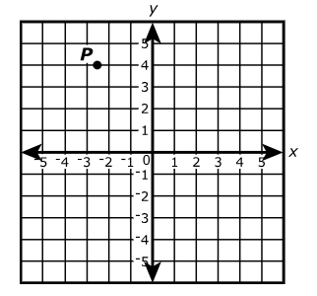  What are the coordinates of point Q? | Sea level is located at an elevation of 0 feet. Here are the elevations of some locations in Death Valley National Park. Determine whether each of these locations has an elevation above sea level or below sea level.  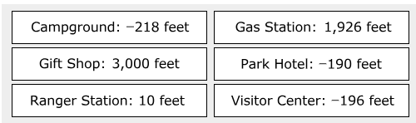
6.NS.6b | 6.NS.6c
Part A: Thomas knows how to plot point J at (- 3, 4) on a coordinate grid. Thomas needs to plot point K at (-3.5, 4). Explain where point K is on the coordinate grid in relation to point J.  Part B: Thomas needs to plot the point (-3.5, -4). Identify any similiarites between the ordered pair for the point K and the ordered piar for point L. Explain which reflection would create point L from point K. | The number line shows four points.  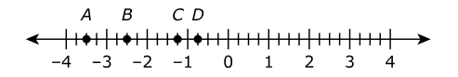  Which point is located at -3/4?
6.G.3 | 6.NS.7a
What is the perimeter, in units, of a polygon with the vertices located at (-7, -3),  (-7, -4), (6, -3), and (6, 4)? | Part A: Select the location of – 2 and -9 on the number line.  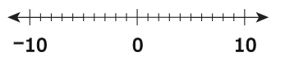  Part B: Use mathematical symbols to write an inequality that compares -2 and -9. Explain how the number line can be used to show that your inequality is correct.
6.NS.6a | 6.NS.5
Points P, Q, and R are shown on the number line.  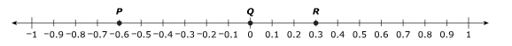  Part A: Find the distance between points P and Q and between points R and Q. Show your work or explain your answers. Refer to the number line in your explanation.  Part B: Point S is a different point on the number line. Point S and point R are the same distance from point Q. Explain how to determine the location of point S on the number line. | Water freezes at 0 degrees Celsius. The table shows five different temperatures in degrees Celsius. Indicate whether each temperature is aboove or below freezing. Select one cell per row.  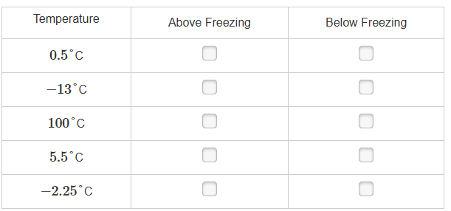
6.NS.6a | 6.G.3
Three values on a number line are labled f, g, and h.  f = -4  g = -g  h = -f  Which number line correctly shows the values of f, g, and h?  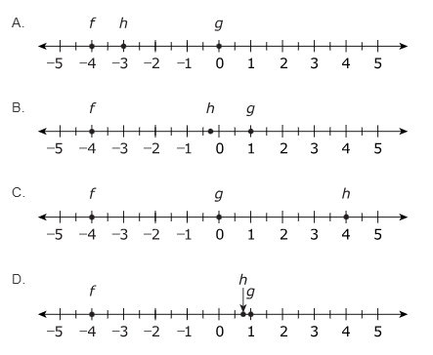 | Points J and K, plotted on the coordinate grid, are two vertices of rectangle JKLM. Rectangle JKLM has an area of 7 square units. Points J is located at (2,), and point K is located at (-5,1). Each vertex of the rectangle is located at a point that has integers coordinates.  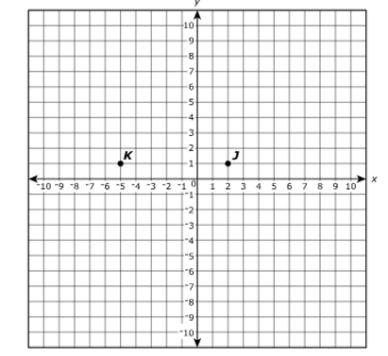  What could be the other points? What is the perimeter of JKLM?
6.NS.6b | 6.NS.6a
The point (2, -4) is reflected across the x-axis. What are the coordinates of the reflected point? | Select a place on the number line to plot the point – (-2)?  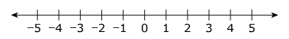
6.NS.7a | 6.NS.7b
These five rational numbers are plotted on a horizontal number line.  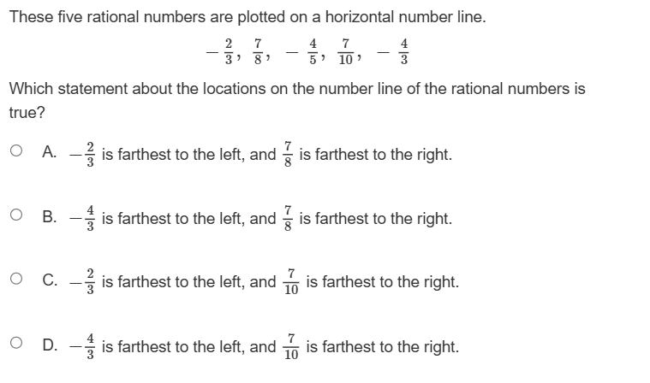  Which statement about their locations on the number line of the rational number is true? | Which statement about the temperatures below is true?  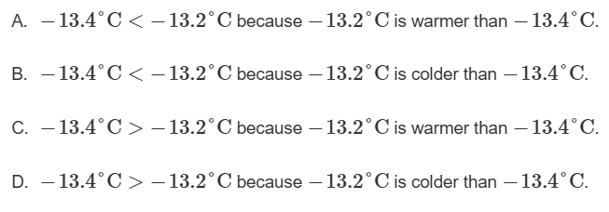
6.NS.7c | 6.NS.7c
Points P, Q, and R are shown on the number line.  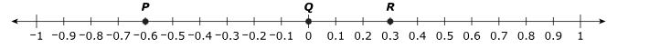  Part A: Find the distances between points P and Q and between points R and Q. Show your work or explain your answers. Refer to the number line in your explanation.  Part B: Point S is a different point on the number line. Point S and point R are the same distance from point Q. Explain how to determine the location of point S on the number line. | Which point shows the location of the number with the greatest absolute value?  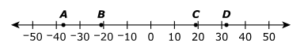
6.NS.8 | 6.NS.8
City planners are creating a neighborhood map on a coordinate grid. The table shows the locations of the neighborhood library and school on a coordinate grid.  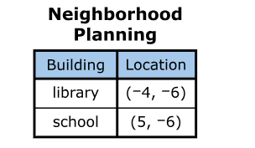  In this coordinate grid, the distance between each gridline represents 1 mile What is the distance, in miles, between the library and the school?  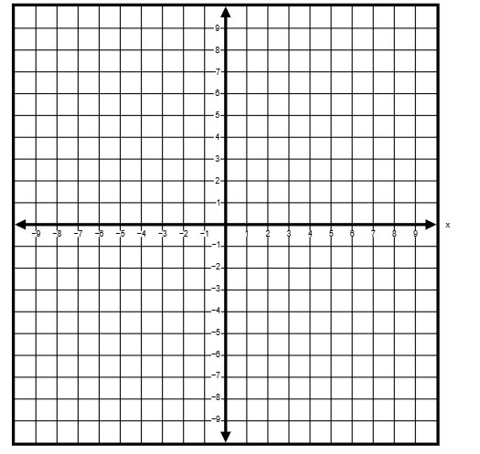 | Point P is located at (-2, -3). A second point on the coordinate grid is location 4 units from point P and has an x-coordinate of -2. What is one location of the second point?  