7.SP.8 | 7.SP.8
- Jonah received a gift card to a movie theater. The gift card allows hime to choose one type of movie, one snack, and one drink. His options are shown in the list below.  - Movies: drama, action, comedy  - Snacks: popcorn, chips, candy  - Drinks: water, juice  He chooses one movie, one snack, and one drink at random. What is the probabilty that Jonah chooses a comedy, chips, and juice? Write your answer as a fraction. | - At a deli, customers buying a sandwich can choose one type of bread, one type of meat, one type of cheese. The options for each sanwich are listed below.  - Bread: white or wheat  - Meat: turkey or beef  - Cheese: american, swiss, or cheddar  Assuming each choice is eqally likely, what is the probabilty a customer will choose a sandwich with white bread, turkey, and swiss cheese?
7.SP.5 | 7.SP.6
- Based on a weather report, the proability that it will rain tomorrow is 0.13. Which word describes the likelihood that it will rain tomorrow? Certain, Impossible, Likely, or Unlikely | - Kerry has a bag containg white and yellow marbles. Kerry randomly select one marble from the bag, records the result, and returns the marble to the bag. The results of the first 65 sections are shown below.  - A white marble was selected 41 times.  - A yellow marble was selected 24 times.  Based on the results, what is the probablity that the next marble Kerry selects, rounded to the nearest percent will be white?
7.SP.7 | 7.SP.6
- A spinner has five equal-sized sections colored blue, red, orange, yellow, and green. The arrow on the spinner was spun 50 times during an experiment. The results are shown in the table below.  Based on the results, what is the experimental probability that on any one spin, the arrow will land on the red section? | Mr. Norton uses a fair spinner with 12 equal regions to determine the topic for each day’s warm-up lesson in math class.  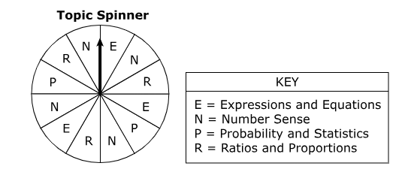  Mr. Norton plans to spin the spinner 120 times during the school year. Create a bar graph that shows the best prediction for the number of times each topic will be selected.
  Results of Experiment
  Color | Frequency
  Blue | 12
  Red | 15
  Orange | 6
  Yellow | 10
  Green | 7
  Relative Frequencies
  Number of Expected Times
   |  | E | N | P | R
   |  | Topics
7.SP.7 | 7.SP.8
A box contains paper clips of three different sizes. The number of each size of a paper clip are listed below.  - 100 small paper clips  - 250 medium paper clips  - 150 large paper clips  One paper clip is randomly selected from the box. What is the probability that the paper clip is selected is either small or medium? | A student tosses a fair coin with heads (H) one one side and tails (T) on the other, and rolls a fair number cube with faces numbered 1 through 6. How many different outcomes are possible.
7.SP.5 | 7.SP.6
A spinner has 12 sections of equal size. The sections are numbered 1 to 12. The arrows on the spinner will be spun once. Consider the following events.  - J is the event that the arrow stops in a section with an even number.  - K is the event that the arrow stops in a section with a number greater than 2.  - L is the event that the arrow stops in the section with the number 10.  What event goes with each of the following: Unlikely, Neither Likely nor Unlikely, Likely | A company sells artwork using a website. Information about the number of people that visited the website and the number of pieces of artwork purchased on a single day is listed below.  - 117 people did not purchase any artwork  - 24 people purchased one piece of artwork  - 9 people purchased more than one piece of artwork  Based on the data that day, what is the probability that the next person to visit the website will purchase more than one piece of artwork?

