[Location:  In- Person] | Session Description: This session will focus on teaching students about linear relationships, including how to represent and analyze them. Teachers will explore strategies for helping students understand slopes, intercepts, and the equations of lines. The session will emphasize modeling and reasoning, where students will solve problems involving linear relationships and explain their reasoning.  Goals: Use NTN Methodologies as a lens to explore the following:  - Analyze the rigor and vertical alignment of the content standards.  - Build conceptual understanding and connect multiple representations.  - Explore rigorous tasks to guide instruction and assess learning.  - Develop teacher capacity to use strategies to build student capacity to solve modeling and reasoning problems  - Analyze the rigor and vertical alignment of the content standards with measure standards and how it relates to Securely Held Knowledge problems  - To build conceptual understanding of linear relationships  Content Training Purpose: The purpose of content training is for participants to explore and engage in conceptual understanding strategies in their current or following unit of study. There may be modeling included but the questioning and honoring of voices/knowledge in the room is paramount. We want to facilitate rich discourse during this time and modeling facilitating these conversations using the 5 practices.  Prep Ahead: Scavenger Hunt  Additional Materials Not in the Black Trainer Kit:  Attendance: Use the QR code on the first screen to take attendance. Check with the district or school if the sign in for the session should be completed at the beginning or the end of the session. Link: bit.ly/ntncheckin  Prep on Arrival:  • Have paper for participants to create name tents.  • Set up session Parking Lot for use with sticky notes.  - Have a plan to post the Scavenger Hunt activity.  . |  | Time:  8:30-3:00  Lunch 11:15-12:15  5.5 Hrs.
Time (Total) | Component | Description | Materials
8:30-9:00  (30 min) | Introduction and Icebreaker | Purpose: To introduce yourself, NTN and set the tone for the session.  - Create Name tents.  - Meet your Presenter: Facilitator Introduction  - NTN Introduction  - Who is NTN and what do we do – Mission, vision, NTN methodologies?  - Ice Breaker Idea: Ice Breaker Idea: Would You Rather?  1. Participants must choose one of the forced choice options (“in-between” or “neither” are not allowed)  2. Use the Zoom screen annotation (Arrow, star, heart, etc.) to select which option you would rather have or do if virtual.  3. In person, consider thumbs up or thumbs down, or for movement, move to one side of the room.  - Agenda: Share the agenda for the day.  Let’s Do Some Math: Notice and Wonder  The purpose of this warm-up is to get a conversation started about what features a graph needs. In the following activities, students will put these ideas to use by adding scale to some axes with two proportional relationships graphed on it.  Launch  Tell students they will look at a picture, and their job is to think of at least one thing they notice and at least one thing they wonder about the picture. Display the problem for all to see and ask students to give a signal when they have noticed or wondered about something.  Used from IM Gr8 IM Lesson 3.1.1  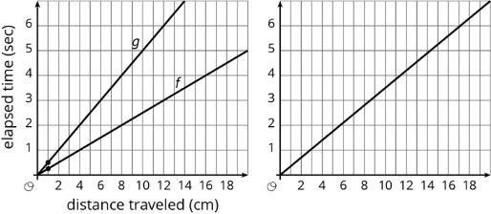  Things Students may Notice (Possible students’ responses – Answers may vary)  - The second set of axes are not labeled.  - If the first graph is about speed, then f is twice as fast as g.  - Graph g is something going a speed of 2 centimeters every second  - Graph f is something going at a pace of about 0.25 seconds per 1 centimeter.  - All the graphs are increasing.  - The first graph has cm and seconds.  - There are letters next to the lines on the first graph.  - The x axis is counting by 2 and the y axis is counting by 1.  Things Students may Wonder (Possible students’ responses – Answers may vary)  What do the two points mean?  Why does one graph show two lines while the other only has one?  Does the second graph measure distance and time?  What do g and f represent?  What does elapsed time mean?  Why do the graphs have letters next to them?  How come the grids on the graph are rectangles and not squares?  Activity Synthesis  Invite students to share the things they noticed and wondered. Record and display their responses for all to see. If possible, record the relevant reasoning on or near the image. After each response, ask the class if they agree or disagree and explain alternative ways of thinking, referring back to the images each time. If the missing labels are not mentioned, make sure to bring them up.  - Is the graph on the right the same as either graph on the left?  - How would you describe the line?  - What types of features are present on the graph?  We want students to begin to notice characteristics of the graphs, such as the graphs are increasing, labels, axis numbers, etc. If students don’t mention a particular characteristic in what they notice or wonder, have questions prepared that support characteristics and mathematical noticing’s.  Review the process and expectations of Notice and Wonder and the purpose.  Remind teachers that the focus should be on providing access points and having students notice characteristics of graphs and precision with graphing.  Process:  What happened during the Notice and Wonder routine?  - The teacher presents diagram with figures, shapes, or numbers or other math concept.  - Students observe and identify what they notice and what they wonder.  - Students share answers verbally. Teachers encourage precision in use of language. Facilitator highlights or asks questions around the math concepts that are intended to be surfaced.  Things to consider:  - Anticipation – teacher planning should happen. Consider possible student responses, and how you could ask questions to support the math take aways that you want to surface, if needed. Consider how you could ask questions based on possible student responses. | NC: 1  Colored Paper  Markers
9:00- 9:25  (25 min) | Unpacking Standards | Purpose: To set the stage as it relates to content through the lens of the content standard and the conceptual understanding strategies that must be present and considered when planning for upcoming lessons in the Unit. This will foster alignment amongst the group. In addition to unpacking the standard some time will be dedicated to the progression of the selected standards to gain insight on what students are familiar with in terms of content, representation as well as where the standard connects to upcoming grade levels. The previous grade level representation should provide teachers will a way to support students in gaining entry/access that the teacher can make to grade level content.  - Present and review the rigor slides.  - Have participants read the prerequisite standard(s) for the unit. Discuss as a group how the standard(s) meets the components of rigor. Discuss how the nouns tell us the knowledge needed and the verbs tell us the skills needed. This is where the trainer helps them understand the 3 components of rigor while asking questions.  - Discuss how the standards for this have changed this year in the numbering and that there are some new standards in NJ for Data Literacy.  - Now present the grade level standards that are in the power point for the unit. (2 to 3 will be given depending on the unit) Have the teachers work together to identify the components of rigor and then share out. The slides will change color based on the component. Note: Some could lend themselves to a lengthy discussion. This discussion helps them break apart the standard and what is needed for them. When needed go back to the slide about what application really means.  - You can share with them that in the note catcher there will be a space for them to note pre-requisites that they note throughout the training that they are wondering about or questioning how this can potentially cause gaps for students.  - Have participants record prerequisites and vocabulary as well as what students need to do to meet the rigor of the standard.  - Remind participants that this is a fluid section throughout the training and that we will also circle back to this at the end.  Note: As a trainer we will continue to reference the standards and rigor throughout the session when covering the content. We need to make sure we understand what the standard is asking. It is important to understand the end goal, key expected takeaways for students, and how this could be assessed.  Use the power point slides to dig into the rigor of the prerequisite with an example that is part of the progression.  As we examine prerequisite standards, if there are ones that are assessed in SHK modeling, they will be included and noted. The 7.EE and 7.RP standards are the standards that are assessed as part of SHK in the modeling section.  As a group, have the teachers determine the rigor in the following standards, using the directions below on the Standards Document Link. Pick 2 to 3 top ones and highlight in grey the ones that you will do the rigor with them. Have the participants work in groups to look at the rest of the standards and decide what the rigor is for them- then share the next slide.  Engage in discussions around deriving slope with slope triangles and the importance of how that builds the conceptual understanding of rise over run and various ways to find average rate of change as this is what it builds to in future courses. This will become SHK for Algebra 1. | Materials  NC: 1 – 2
  Standard | Description | Rigor
  7.RP.2 | Recognize and represent proportional relationships between quantities. | Procedural Skill/Fluency
  7.EE.4 | Use variables to represent quantities in a real-world or mathematical problem and construct simple equations and inequalities to solve problems by reasoning about the quantities. | Conceptual  Procedural Skill/Fluency  Application
  Standard | Description | Rigor
  8.EE.5 | Graph proportional relationships, interpreting the unit rate as the slope of the graph. Compare two different proportional relationships represented in different ways. For example, compare a distance-time graph to a distance-time equation to determine which of two moving objects has greater speed. | Conceptual  Procedural Skill/Fluency  Application
  8.EE.6 | Use similar triangles to explain why the slope m is the same between any two distinct points on a non-vertical line in the coordinate plane; derive the equation y = mx for a line through the origin and the equation y = mx + b for a line intercepting the vertical axis at b. | Conceptual
  8.F.1 | Understand that a function is a rule that assigns to each input exactly one output. The graph of a function is the set of ordered pairs consisting of an input and the corresponding output. (Function notation is not required in this grade level.) | Conceptual
  8.F.3 | Interpret the equation y = mx + b as defining a linear function, whose graph is a straight line; categorize functions as linear or nonlinear when given equations, graphs, or tables. For example, the function A = s2 giving the area of a square as a function of its side length is not linear because its graph contains the points (1, 1), (2, 4) and (3, 9), which are not on a straight line. | Conceptual  Procedural Skill/Fluency
  8.F.4 | Construct a function to model a linear relationship between two quantities. Determine the rate of change and initial value of the function from a description of a relationship or from two (x, y) values, including reading these from a table or from a graph. Interpret the rate of change and initial value of a linear function in terms of the situation it models, and in terms of its graph or a table of values. | Conceptual  Procedural Skill/Fluency
  8.F.5 | Describe qualitatively the functional relationship between two quantities by analyzing a graph (e.g., where the function is increasing or decreasing, linear or nonlinear). Sketch a graph that exhibits the qualitative features of a function that has been described verbally. | Conceptual
9:25 – 9:30  5 min | Identify Similar Triangles  KEMS Lesson 12- Similar Triangles as Slope | Identify Similar Triangles  - Discuss observations of triangles 1 & 2 on S150. Include “corresponding sides” in discussion.  - Have participants engage in the activity in pairs on S151, using the modeling boxes to guide the discussion.  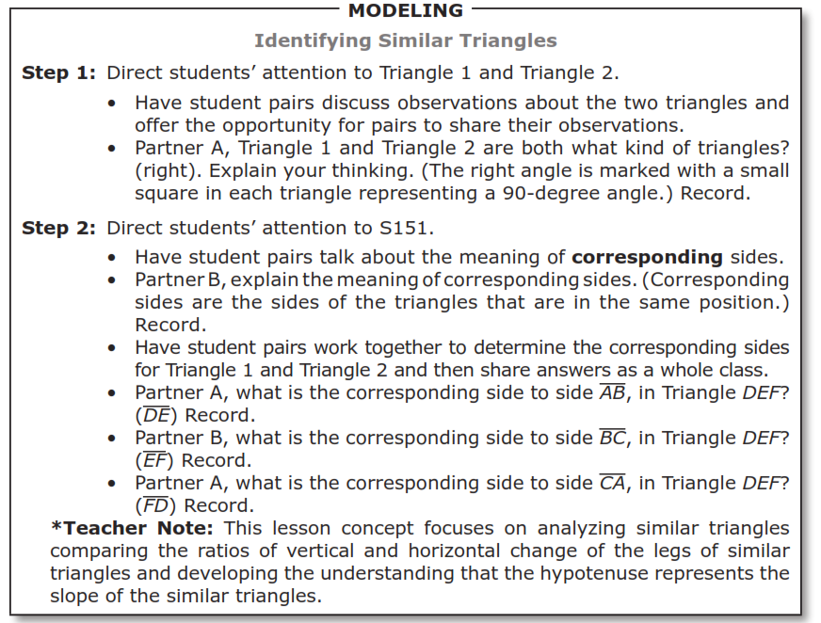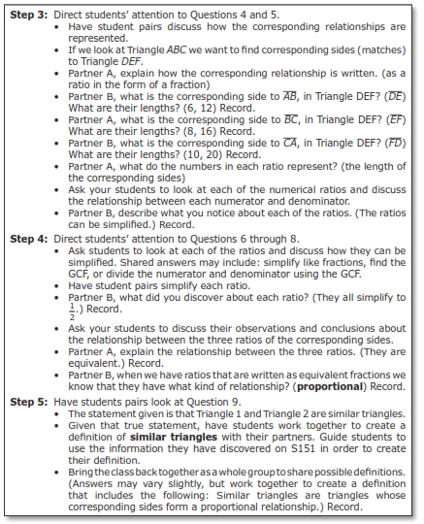  - Discuss questions that follow, leading to the knowledge that the ratio between each of the corresponding side lengths between triangle 1 and triangle 2 is ½. This then leads to a definition for “similar triangles.”  - Discuss example on S151 as it leads to seeing that we can also determine if two ratios are proportional by multiplying the cross products to see if they are equal.  - How does this activity set students up to be successful with 8.EE.6? | S150 – S151  NC: 3 – 4  Colored Pencils, Wall Coordinate Plane, Rulers
9:30 – 9:55  25 min | Similar Triangles on the Coordinate Plane  KEMS Lesson 12- Similar Triangles as Slope | Similar Triangles on the Coordinate Plane (S153-S156)  - This section continues the building towards similar triangles as slope and making connections.  - In this section, we use plotting points on the coordinate plane to create right triangles. The measure of the vertical and horizontal legs is then identified in units and used to create ratios. Participants will need rulers and colored pencils.  - Utilize the coordinate wall chart to graph similar triangles on S153 using sticky dots to mark each coordinate point and string to connect the points to form each triangle. Have participants place the dots on the wall chart and suggest that they have students do this to promote student participation in the lesson. This is explained in the model boxes below.  - Talk through the series of questions on S154 to discuss how students are guided to make the connection between vertical leg/horizontal leg and slope of the hypotenuse of each triangle. The ratio of the vertical leg to the horizontal leg is the slope of a right triangle. When we create lines, slopes of segments of the line can be identified using this strategy, this finding the slope, or rate of change of the line.  - Lines have a constant rate of change.  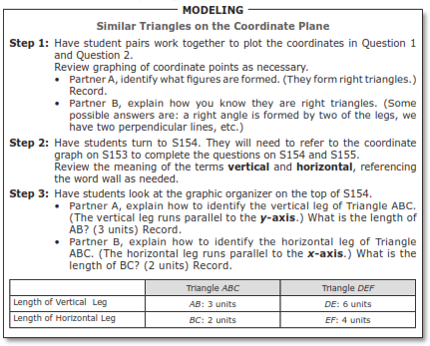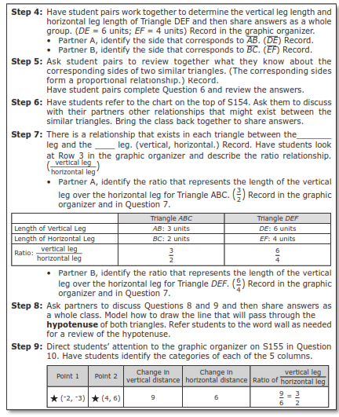  - Have the pairs work together to continue on S155 using the directions in the modeling boxes.  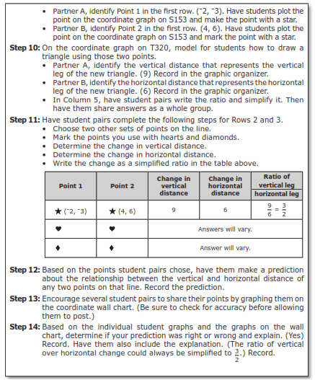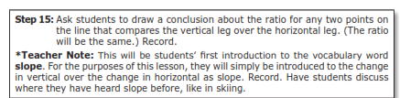  - The term “hypotenuse” is addressed as well as drawing one line that goes through the hypotenuse of both triangles (connects to 8.EE.B.6 – use similar triangles to explain why the slope m is the same between any two distinct points on a non-vertical line in the coordinate plane). This builds on S156 to the understanding that the ratio of the measure of the vertical leg over the horizontal leg is also known as the “slope.”  - The ratio of the vertical leg to the horizontal leg is the slope of a right triangle. When we create lines, slopes of segments of the line can be identified using this strategy, this finding the slope, or rate of change of the line.  - Lines have a constant rate of change. | S153 – S155  NC: 5 – 7  Colored Pencils, Wall Coordinate Plane, Rulers
9:55 – 10:05 | Positive Vertical and Horizontal Change  KEMS Lesson 13- Unit Rate as Slope | Positive Vertical and Horizontal Change  - Model problems 1- 12. Use a red pen to show the vertical distance (1).  - Use a blue pen to show the horizontal distance (5).  - Discuss Question 9 on the bottom of page S163 rate of change and the different ways to describe it.  Rate of change =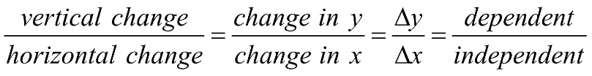  - Use the Modeling boxes to support the conversation, amplifying the key vocabulary highlighted throughout the modeling boxes..  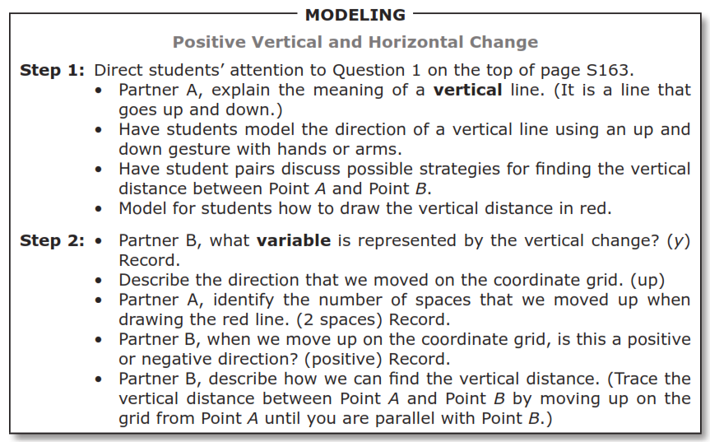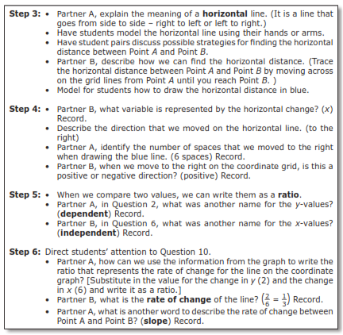  - Support students in the understanding that rate of change and slope are the words used to describe how the line moves. The rate of change in it’s simplest form describes the vertical movement for every one unit of horizontal movement.  - 1/3 means that we move up 1/3 of a unit for every unit we move right.  - This line is not directly proportional because it does not intersect the y-axis at the origin. | S163  NC: 8
10:05 – 10:10 | Negative Vertical and Horizontal Change  KEMS Lesson 13- Unit Rate as Slope | Negative Vertical and Horizontal Change  - Discuss discovery of independence of direction for rate of change calculation shown on the problem on the next page S164 being the same problem finding the rate of change from point B to point A (instead of point A to point B).  - For this training use the PPT slides or model for participants, sharing how this would be discovered by students through this exploration.  - Discuss the differences between how the triangle was sketched from the last activity and why it does not make a difference in the final answer.  - Rate of change involves both the vertical and horizontal distance and the direction you are moving.  - You must be consistent in creating the triangle based on where you begin and end to determine direction.  - Students should understand that the is more than one way to create a triangle.  - Precision around choosing values that cross at gridlines in critical for understanding when determining slope from a graph.(SMP 6)  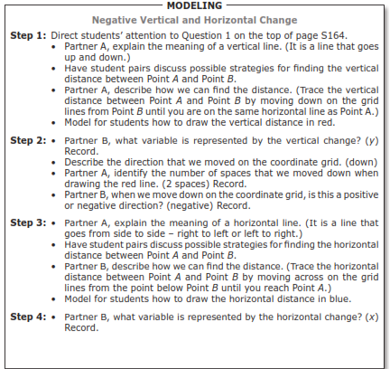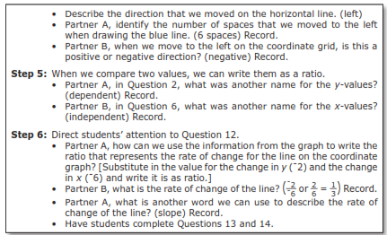 | S164  NC: 9
10:10 -10:35 | Exploring Modeling and Reasoning Through the Lens of SMP’s | Exploring Modeling and Reasoning with SMP’s  - What Does Research Say – Review the quote with participants and discuss the idea of using tasks to provide multiple entry points.  Effective teaching of mathematics engages students in solving and discussing tasks that promote mathematical reasoning and problem solving and allow multiple entry points and varied solution strategies. (National Council of Teachers of Mathematics. "Principles to Action." pg. 17)  - Discuss the educator’s role in problem solving and the reasons why we want to pay attention to SMP’s.  - Idea is to support problem solving without take over the process of thinking.  - Provide opportunities to use and engage with Standards of Mathematical Practice (SMP’s)  - Intentionally plan for entry points  - Provide instruction with multiple strategies  - Cultivate conversation by providing opportunities to simultaneously make meaning, communicate that meaning, and refine the way content understandings are communicate  - Review the 8 SMP’s  - Why pay attention to SMP’s?  - Summarize the way mathematicians work  - Provide untapped opportunities for students to engage in rich mathematical reasoning.  - Meeting the Supporting Actors – SMP 3, 4, 5 and 6 – How are the Supporting Actors Revealed in Modeling and Reasoning?  - All SMP’s are not create equal. Share the slide with the diagram. All are under SMP 1. SMP 2, SMP 7 and SMP 8 are the lead actors which can be referred to as the Avenues of Thinking. They are usually the natural ways that people tend to solve problems.  - SMP 3, SMP4, SMP5 and SMP 6 support the work and should be evident in all types of problem solving, especially with modeling and reasoning. Let’s examine why. Have participants examine the diagram and see how these are meant to support all the Avenue’s of Thinking.  - SMP 5 – Use appropriate tools strategically- Share the first 3 sentences for SMP 5.  - SMP 5 – First 3 sentences - Mathematically proficient students consider the available tools when solving a mathematical problem. These tools might include pencils and paper, concrete models, a ruler, a protractor, a calculator, a spreadsheet, a computer algebra system, a statistical package, or dynamic geometry software. Proficient students are sufficiently familiar with tools appropriate for their grade or course to make sound decisions about when each of these tools might be helpful, recognizing both the insight to be gained and their limitations.  - SMP 3 – Explain your thinking and path.  - SMP 6 – Attend to Precision- Share sentences below from SMP 6.  - SMP 6 Quote – “Mathematically proficient students try to communicate precisely with others. They calculate accurately and efficiently, express numerical answers with a degree of precision appropriate for the problem context.”  The focus of Modeling Questions is SMP 4. Students need to be able to explain a pathway. They also need to use precision and tools within their path.  - SMP 4 – Model with Mathematics- Share middle sentences from SMP 4  - SMP 4 Quote – “Mathematically proficient students who can apply what they know are comfortable making assumptions and approximations to simplify a complicated situation, realizing that these may need revision later. They can identify important quantities in a practical situation and map their relationships using such tools as diagrams, two-way tables, graphs, flowcharts and formulas. They can analyze those relationships mathematically to draw conclusions.  - Share the slide with the Avenues of Thinking and have participants consider how these can be used to support building student capacity with the modeling and reasoning problems.  - Building Student Capacity with Avenues of Thinking -share the quote  “Teachers must decide what aspect of a task to highlight, how to organize and orchestrate the work of the students, what questions to ask to challenge those with varied level of expertise and how to support student without taking over the process of thinking for them and thus eliminating the challenge.” National Council of Teachers of Mathematics. Principles to Action. pg. 22.  - Examine the subclaim from the grade band that has reasoning and Modeling to show an example of how the SMP’s are incorporated into the Evidence Statements.  - Since 3 – 5 and then 6 – 8 are similar, there will be an example to show where the SMP’s are evident for each grade band. Please hide the one you do not need.  - Have participants reflect and share on the Reflecting on SMP’s slide.  - How does engaging intentional sharing of work with sequencing work samples support building student capacity for reasoning?  - Where do you see yourself with the Avenues of Thinking?  - Is there a pathway to this problem that most appeals to your way of thinking? | NC: 10
  Think Quantities! | Think Structure! | Think Repetition!
  What can I count?  What can I measure?  How are the quantities related?  How can I represent the quantities so I can see relationships? | How is this situation behaving?  What kind of problem is this?  Does the problem remind me of another I’ve solved?  Will changing the form help?  How can I chunk this expressions/number/visual? | Is there a process that keeps repeating?  Am I counting /building/drawing in the same way each time?  Do I keep repeating the same calculations?  How can I use repetition to write a rule?
10:35 - 10:50 | Building Capacity  Understanding  Reasoning Problems | Building Capacity – Understanding Reasoning Problems  Have participants refer to Note Catcher, Understanding Reasoning Questions Chart, to record ideas and take aways around Reasoning problems during this section.  What’s the Difference between a Reasoning and a Modeling Questions?  Both types of questions are considered constructed responses. When we work with prompts in English, we support students in identifying the type of writing they are being asked to do. The same is true in math. There are some ways that we can tell the difference between a modeling and a reasoning problem.  Assessing Reasoning – Understanding how to Answer a Reasoning Problem.  - The questions on the slide are to discuss with the group to see where they are with helping students answer a reasoning problem.  - What do students have to be able to do to be successful with these problems?  - How do we build student capacity to express their reasoning in writing?  - What questions should students ask themselves?  - * Problems often do contain a computation component that could be worth 1 or 2 points.  - How often do you ask these types of questions?  - Describe the reasoning: Explain the logical pattern or thought process behind each step.  - Explain why: Justify why the steps or reasoning lead to the expected outcome or why they address the problem.  - Connect concepts: Illustrate how different methods, strategies, or models are applied to reach the solution.  - Analyze errors: Identify mistakes and describe the reasoning that corrects them.  - Verify reasoning: Check if the logical steps align with the correct solution and explain any discrepancies.  - Wording Used to Indicate Type of Reasoning – These are the different types of wording. There is usually something specific that  - Describe or explain the pattern . . .  - Explain why the quantities/expressions/equations are equivalent  - Explain why area is same  - Explain how to use number line/model (particular strategy specified) to . . .  - Explain two different ways to . . .  - Explain the error in student’s work . .  - Describe and fix the error in . . .  - Verify student’s conclusion with your work  - If correct, then . . . If incorrect, then . . .  Why Reasoning?  - Show a reasoning problem from the grade level. (See below in next section. Problem also in PPT. Change out problem and questions in PPT based on grade.)  - The goal this slide is to determine if teachers can understand how this type of problem should be answered.  - As the facilitator ask, “How do we know this is a reasoning problem?” We want to surface the idea that this is a reasoning problem because it contains the following:  - There is a computation component – Students need to find the time that Casey began cleaning her room.  - There is a reasoning component – Students are asked to explain using a particular model, which is the number line.  - With reasoning, both components, the computation component and the reasoning component need to be addressed.  - The type of reasoning that is asked for should be articulated.  - Facilitator Note: An explanation is usually asked for in reasoning problems. This is where the chain of reasoning is expected to be developed or flawed reasoning is expected to be identified and corrected.  - What are you being asked to do to solve the computation part?  - What are you being asked to explain?  - Include the evidence statement and the focus on the idea of the chain of reasoning. Change out statement based on problem chosen and grade.  - 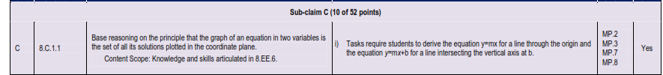  - Facilitator- Discuss the statement below on the next few slides and how we can use student work samples to build student capacity. Have them consider what they do now and share some strategies they could use to support students in precision with notation and writing.  - Statement made in all the Evidence statements around use of notation: For example, rubrics award less than full credit for the presence of nonsense statements such as 1 + 4 = 5 + 7 = 12, even if the final answer is correct.  - While there is reasoning here, the chain of reasoning is considered invalid. We need to work to build student capacity to use symbols appropriately. While we know exactly what students might mean, the precision here is not considered to be present.  - Diagrams and algorithms are expected to be connected by students when presented and the connections explained.  - As teachers, we can sometimes say, “I get what they mean.” We need to build on what students have and work towards helping students refine their answers moving towards precision in both notation and written chains of reasoning. | NC: 10 – 11
  Reasoning | Modeling
  Error analysis  Explaining or justifying a particular model  Explaining equivalency | A multi-step problem  Creating a solution path  Creating and equation and solving it  A Type 1 portion incorporated
  Start with the problem: Identify the Computation Question to Solve and Type of Reasoning
  Using an Identified Model Type: The problem should be clearly defined and come directly from the question being asked.
  Explain a Model:
  Step 1: Describe the first action or step to address the question using the model.
  Step 2: Describe the next step.
  Continue connecting each step logically.
  Summarize: Conclude by summarizing how the steps taken solve the problem using the particular model.
  Identify the Error Type : Start by pinpointing the mistake or incorrect step in the solution.
  Understand the error: Explain why this step is incorrect and what the correct reasoning or process should be.
  Correct the error:
  Step 1: Describe the first action or step to correct the mistake.
  Step 2: Describe the next correct step.
  Continue connecting each step logically to correct the error.
  Summarize: Conclude by summarizing how the corrected steps lead to the correct solution and prevent the error from happening again.
10:50-11:15 | Reasoning Activity 2 – Keeping Score | Activity 2 for Reasoning – Keeping Score  Remind participants refer the Note Catcher to add additional thoughts, ideas and take aways around Reasoning problems during this section as they engage in the activity.  Facilitator Note: The facilitator should complete the problem and use various strategies in preparation for the session.  Have participants refer to Note Catcher, Understanding Modeling Questions Chart, to record ideas and take aways around Modeling problems during this section.  - Launching Reasoning Activity - Keeping Score  - Review the problem and discuss some of the key points of the problem with teachers.  - How do you know this is a reasoning problem?  - What do you believe a key part of the scoring will be?  - How do strategies we addressed in the content training section support this problem?  - Note – we want participants to understand that reasoning the answer through the use of the model is a key part of the scoring for this problem.  Reasoning Question – 8.C.5 – 1  Used from: NJ Released Questions – 8.C.5-1 – Expressions and Equations – VH7137  Similar triangles ABE and BCD are shown on the coordinate plane. Line t passes through points A, B, and C  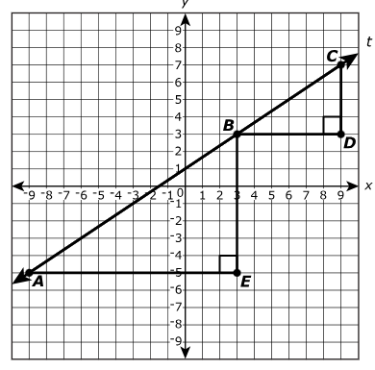  Part A  The slope of the segment AB is _________________________________ the slope of segment BC.  (greater than, less than, equal to)  Part B  Use the ratios of the side lengths of triangle ABE and triangle BCD to explain your answer to Part A.  Part C  Write an equation for line t. Show or explain how you determined your equation.  Activity Considerations  - The number of anchor papers for the activity will be a consideration in how the groups and anchor papers are divided.  - In preparation for the session, determine how you plan to divide the anchor papers and the participants into groups of 3 and assign the anchor papers.  - Depending on the size of the group, plan that at least 2 groups should have the same student samples to score.  - For example, if there are 6 groups and 6 anchor papers, have group 1 and 4, have the same 2 sets to score, group 2 and 5 have another set to score, and group 3 and 6 another set to score.  - If there are only 3 groups, consider giving each group the same anchor papers that was scored a zero, and then 2 other sets so that that every group has 3 sets and at least one overlapping paper. (A- Stands for Anchor Paper) Be discerning about the scores and the papers that are chosen if all papers are not being used.  - Example – Group 1 – Anchor Paper 5, A1, A3  Group 2 - Anchor Paper 5, A4, A3  Group 3 – Anchor Paper 5, A4, A1  Activity Directions  - Have a plan to divide participants into groups of 3.  - Provide each group with a work sample from a reasoning problem from the grade level (see Copy Master Reasoning for the Work Samples)  - Provide each group with a copy of the scoring rubric for the problem.  - Have teachers work in their groups to score the papers.  Activity Reflection – Full Group Share  - Return as a group and post the sample that the group scored and have a group discussion about the score after the group shares how they scored it and why.  - What misconceptions surfaced in student work samples?  - How can you address some of the misconceptions?  - How does the use of the rubric and engaging in a scoring activity support building student capacity to refine answers.  Synthesis  - Have participants add to and share from Note Catcher, Understanding Reasoning Questions chart, any thoughts, ideas and take aways around Reasoning problems that they recorded. | Materials:  NC: 11  Scoring Rubric for the Reasoning Problem (1 per group)  Copy Master for with Anchor Papers without the scores  Trainer will need to plan for the number of Copy Masters needed of the Anchor Paper based on number of groups and plan for dividing groups.  Trainer Reference with Anchor Paper Score (for Trainer only)
11:15- 12:15 | Lunch
12:15 – 12:30 | Scavenger Hunt  Unit Rate as Slope | Scavenger Hunt  Participants will be completing the Scavenger Hunt in pairs. Go over the instructions and also explain that a Scavenger Hunt can also be completed as a Chain Reaction.  - ELL Tip: Thoughtful partnering.  - Management Tip: Having some sort of prize for all partnerships that finish the hunt is a great motivator. If you have partnerships that struggle a great deal, you may want to have a student(s) that is done assist them. You may also want to consider having students create a SOLVE problem or complete a math puzzle when they are finished.  - SpEd Tip: You may have to adjust this activity due to space available for setting up the scavenger hunt. This can be done in the classroom, hallway, or commons depending on the set-up of the school. Also consider doing partners with higher levels and lower levels so all groups can be successful.  - As participants complete the scavenger hunt have a follow up activity for them – ex. create a solve problem for equations.  - Management Tip: This may be quite challenging for some kids, so you may want to give a clue or two to those who struggle.  - Students will work 50 problems trying to complete the puzzle, but if you gave them 50 problems, they would go back to just finding an answer.  - If you don’t use number tiles, make sure they use a pencil.  - Can use Chain Reaction games as scavenger hunts and vice versa.  Scavenger Hunt  - Complete scavenger hunt in pairs.  - Be sure to model expectations for this activity prior to getting started.  - Stay with partner entire time.  - If in hallway for scavenger hunt – establish expectable noise level.  - When completed, what should students work on?  - What will students do if asked to leave the hallway due to noise level?  - A “How to do…Scavenger Hunt” document is located on T981-T982.  - Discuss student worksheet master.  - Discuss answer key along the bottom edge.  How to check a scavenger hunt.  - Each pair should return to their starting poster.  - Pick any pair to begin. Have students find that poster letter on their answer sheet.  - They need to read the problem and explain how to find the answer.  - The pair with the poster with the answer should then read the problem and how to find the answer.  - Continue until all posters have been used.  How to make a scavenger hunt  - Walk through steps together to make your own scavenger hunt.  Organization Tip: It’s imperative to have your posters made BEFORE class and set up prior to students entering. Set up a template on your computer for the posters. Each time you have a Scavenger Hunt to complete, you can simply copy that file and change the problems. You can label the outside of the posters AFTER they print.  - Have the participants do as much of the Scavenger Hunt as they can in the 15-minute period.  - Discuss how this supports building fluency and working with proportional relationships. | Create Scavenger Hunt  T984 – T987  Unit Rate as Slope
12:30 – 12:50 | Representations of Proportional Relationships  KEMS Lesson 14- Comparing Proportional Relationships | Representations of Proportional Relationships  - Review strategies to find unit rates from the three problems on unit rate on the PPT slide from S176. (This will only be on the PPT, not in the Note catcher.)  - This is a proportional relationship and for this section, we are working with proportional relationships. (Connection to SHK with Grade 7)  - What does that mean graphically? (crosses the graph at the origin)  - What does that mean on a table of values? (y/x gives you the unit rate for all cases, (0,0) would be on the table)  - What does that mean for the equation? (The y-intercept is 0. The unit rate is the slope or rate of change)  - Use the modeling boxes and work through the problems on S177 and S178.  - Highlight the differences and the way different information is presented.  - Working with multiple representations and using one representation to complete another should be a focus of this portion of exploration. Highlight ways to support students in seeing the connections.  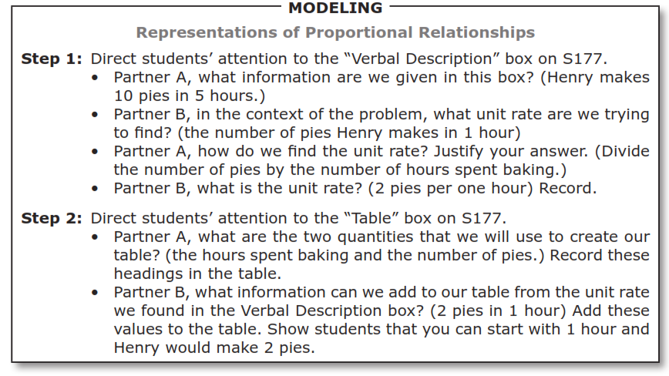  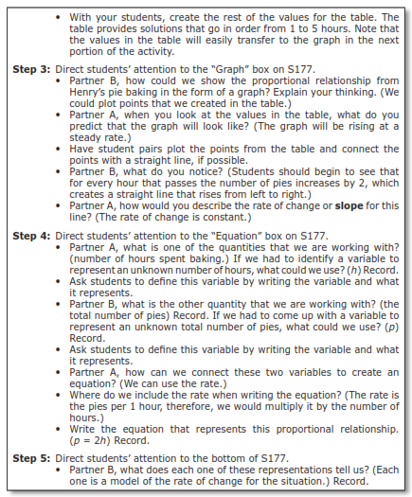 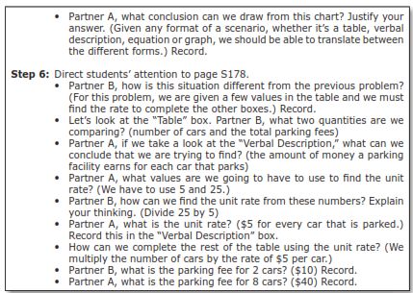+  - Understanding that the relationships are proportional, as it states in the problem is a key to being able to identify the rate of change with given information. | S177 – S178  NC: 12-13
12:50 – 1:15 | Conceptual Understanding to Support Assessment | Conceptual Understanding to Support Assessment- Comparing Proportional Relationships (S183)  - Have participants complete the section from comparing proportional relationships as an introduction.  - Students will be asked to compare proportional relationships presented in different forms or identify another form based on the form that is given.  - Discuss questions below from KEMS.  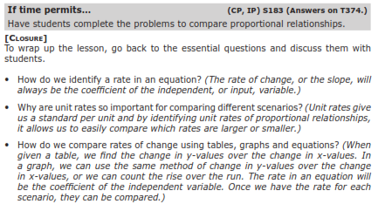  - How does the activity we just engaged with support students in interpreting and answering these types of questions.  - Can they find the unit rate?  - Could the create a table?  - Could they match points on the graph to the situation?  - Have participants work in pairs and on a sheet of paper, create the four representations for each function based on the information provided in the problem. Use gridded index cards to create the graphs.  - Then have them decide what representations they believed were most effective in helping them compare the functions and determine the answer.  - Have each group share out.  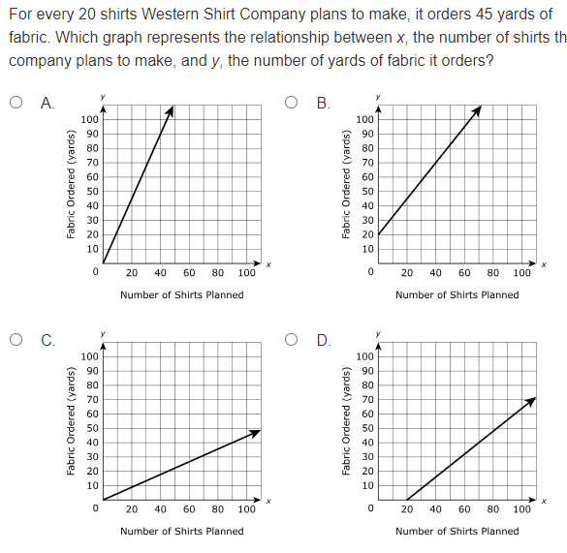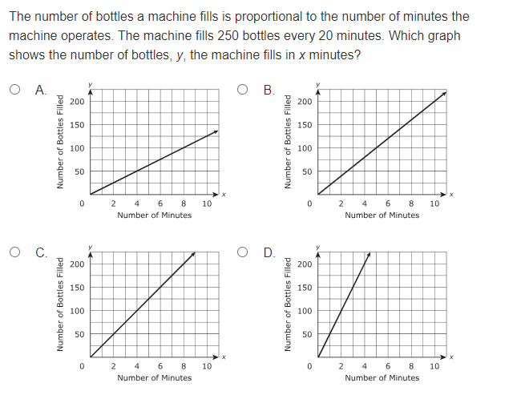  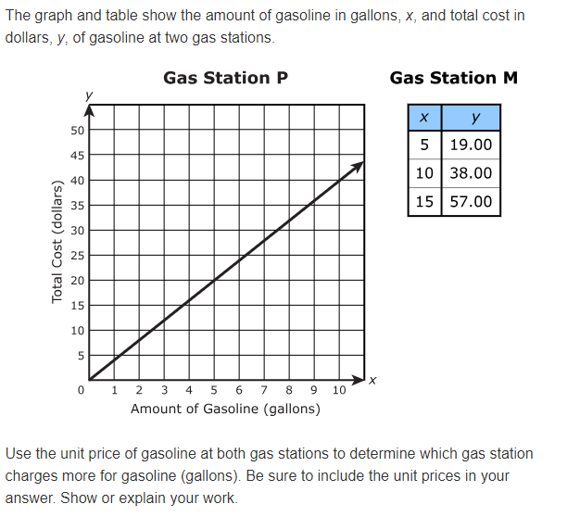 | S183  NC: 14 - 16  Gridded Index cards
1:15 – 1:45 | Compare Functions with Verbal Descriptions and Graphs/ Comparing Rate of Change | Compare Functions with Verbal Descriptions and Graphs/ Comparing Rate of Change (S269-S270)  - We are moving to comparing functions that are not proportional, meaning that they have a y-intercept that is not 0.  - Students would engage in developing and deriving the equation of a line prior to engaging in this section as well as some key ideas around functions.  - The slope or rate of change of a line can be determined with slope triangles, or the ratio of the change in output to the change in input.  - For Grade 8, the y-intercept is often determined graphically, or when x=0 on a table.  - Discuss the types of functions seen on the pages (S269 and S70).  - Discuss how to find the rate of change for each type of function and how to determine the equation of each function.  - While creating a table is not part of the sheet, that is often an access point for student in determine rate change.  - Using the modeling boxes, work through the problems on page S269. These often show up in reasoning in NJ testing.  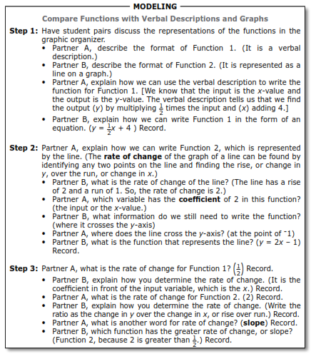  - Discuss how students can analyze the functions to determine which has the greatest rate of change.  - Have partners work together to complete page S270, Comparing Rate of Change and share have participants share out. Consider having 4 groups share for how they determined the rate of change.  - Have several groups share the explanation and discuss how they used the work to determine and create a chain of reasoning for their answer.  - Share the two problems for 8.F.2 to show how this could be assessed.  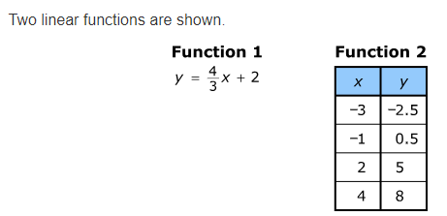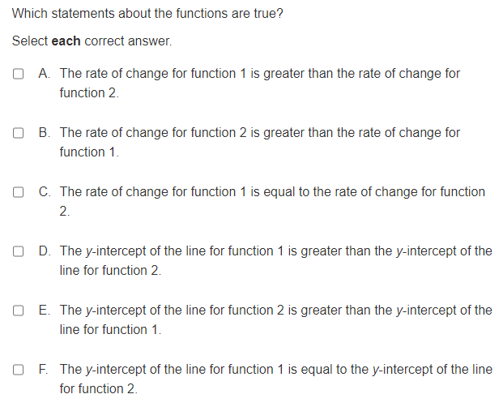  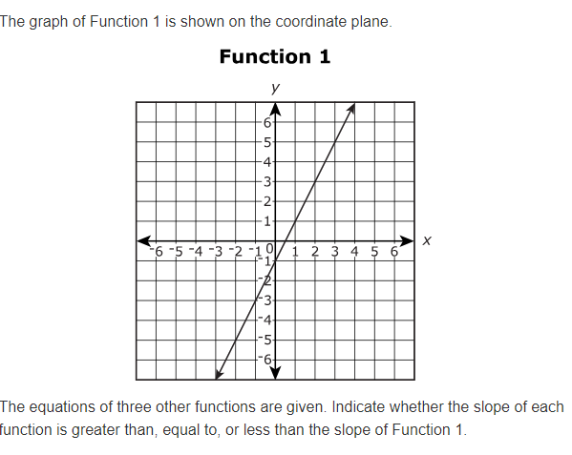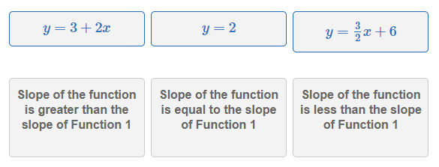 | S269 – S270  NC: 17-18  Colored Pencils
1:45 – 1:55 | Building Capacity: Understanding Modeling Problems | Building Capacity: Understanding Modeling Problems  Have participants refer to Note Catcher, Understanding Modeling Questions Chart, to record ideas and take aways around Modeling problems during this section.  Understanding How to Answer a Modeling Problem (Facilitator- Discuss the statements below and expectations around modeling problems.)  Questions:(Through questions below surface the ideas with the bullet points around modeling)  - What do students have to be able to do to be successful with these problems?  - How do we build students’ capacity to express their modeling in showing their work and expressing context?  - What questions should students ask themselves?  - In modeling problems, there is computation competent. This earns points in the problem.  - Work and a contextual answer are usually expected.  - The solution path needs to be clearly expressed and lead to the answer.  - The flow of the work needs to be able to be followed by another person, so that a clear path to the answer can be ascertained.  - Models should be incorporated.  Questions That Involve Modeling  - What strategy would you use: Identify a strategy or model that would lead to a solution  - Write and expression and use it to solve: Create an expression or equation and use that to solve a problem  - Connect concepts through use of models: Illustrate how different methods, strategies, or models are applied to reach the solution.  - Show your solution path: Check if there is a clearly expressed path that aligns with the solution  Commonalities in Modeling Questions  - Strategy to solve problem isn’t specified.  - Solve and show your work for multi-step problem.  - Problems are multi-step  - Context for answer is expected.  Identifying a Modeling Problem  - Answer . . . and show your work.  - Write and expression and use it to solve . . .  - Write an equation and use it to solve . . .  - Enter your equation, answer and explanation in the space provided.  - Enter your answer in the box, then explain . . .  Considerations in Assessment of Modeling (Facilitator should review these types of problems and have clear understanding to support the discussion. Questions around these types of problems should be answered for participants as needed.)  - There are OGL problems which stands for On Grade Level and SHK problems, which stands for securely held knowledge.  - OGL focuses on particular domains in the grade level for which students are expected so understand and model pathways with strategies to solve problems.  - SHK stands for Securely Held Knowledge. The problems focus on standards from the previous grade level that are prerequisite standards that students need to have a solid understanding and be able to model and use various strategies to solve to engage with grade level content.  - Students are expected to use some type of model or strategy and show the solution pathway for solving modeling problems. The work on how the solution was found is expected to be shown and be clearly followed and understood by the reader.  - Consider the strategies that have been shared during the content portion.  Review the idea of Avenues of Thinking – students should be including some type of model that connect with context  - Students need to learn to develop various pathways. Do they see patterns? A structure? A process that is repeating or that they can repeat.  - Review modeling Evidence statements to show the SMP 4 connection to models. Models usually follow one of the pathways for Avenues of Thinking.  - Note the D.1 is on Grade level for Sub-Claim A Evidence statements.  - Note that in D.2, the domains for 7.NS.3, 7.EE, 7.G and 7.SP.B are specified as the standards for SHK.  - Reflect on key take aways and what participants recorded on their Understanding Modeling Questions chart on the NC.  - In Grade 6- 8, there is a set of modeling problems that include estimation. Students are expected to estimate and share the strategy they used to estimate, as well as then line up and share the plan and answer the rest of the question.  - There is also a D.3 category which will be discussed in a later session. | NC: 19
  Think Quantities! | Think Structure! | Think Repetition!
  What can I count?  What can I measure?  How are the quantities related?  How can I represent the quantities so I can see relationships? | How is this situation behaving?  What kind of problem is this?  Does the problem remind me of another I’ve solved?  Will changing the form help?  How can I chunk this expressions/number/visual? | Is there a process that keeps repeating?  Am I counting /building/drawing in the same way each time?  Do I keep repeating the same calculations?  How can I use repetition to write a rule?
1:55 – 2:40 | Modeling Problems – Activity 1  Creating a Path | Activity 1 for Modeling – Creating a Path  Remind participants refer to Note Catcher, Understanding Modeling Questions to add additional thoughts, ideas and take aways around Modeling problems during this section as they engage in the activity.  Facilitator Note: The facilitator should complete the problem and use various strategies in preparation for the session.  - Launching Modeling Activity - Creating a Path - Have participants use the problem from the Note Catcher.  - Review the problem and discuss some of the key points of the problem with teachers.  - How do you know this is a Modeling problem?  - This is a D.2 problem. How does this address prerequisite skills?  - Why is this part (C) free response? What models could be used?  Facilitator Notes to highlight in discussion around problem. If these don’t surface through conversation in launch, consider using questioning to highlight connections.  - Note that for this problem, this is a D.2 which addresses prior grade level standards. It connects to the mass and grams, with some of the same types of strategies that could be used with measurement, but address measurement units from Grade 2.  - Number lines could be used as a model just as they were used with time. This also reinforces the adding and subtracting which surfaces often throughout the measurement unit and is often part of D.2 Modeling Problems.  - How could you create a model to support answering the question?  - Remind participants that they can refer to the Avenues of Thinking Chart on Page 22 as they consider a pathway to solve.  Modeling Question – D.1  Used from: NJ Released Questions – 8.D.1 – Expressions and Equations – VF655990  A company uses a new machine and an old machine to print booklets. Each machine prints booklets at a constant rate. The graph and the equation represent the relationships between x, the number of minutes the machines print, and y, the number of booklets printed.  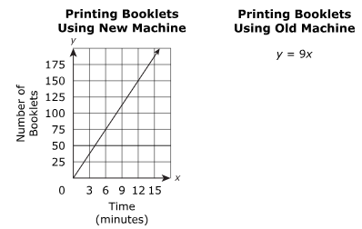  The company uses both machines to print a total of 1,250 booklets. Both machines start printing at the same time. During printing, the old machine breaks down and stops printing. The new machine continues printing for an additional 14 minutes and completes the order.  What is the total number of minutes the new machine prints? Show or explain all your work.  - Consider sharing different pathways such as creating a table to examine structure, creating a patterns to develop a possible equation,  Activity Directions – Creating a Path  - Provide teachers with a picture that shows a gameboard path on the PPT slide. They will create the path as they solve the problem, using multiple sheets of 8 x 11 colored (or white) paper. The idea is to have students begin to envision problem solving as a pathway.  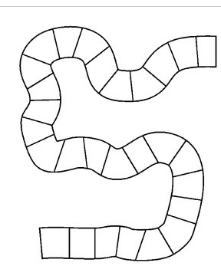  - Participants should be divided into groups of 3.  - The problem is on the Note Catcher which they will refer to throughout the activity.  - Share the directions for the activity on the slides.  - On the first sheet of paper, have them write the context and what the questions are asking.  - On the second sheet, have them write information needed to solve the problem, including quantities and relationships. Both unknown and implied as well as stated quantities should be considered.  - Choose a strategy and create a path, with each portion of the path on a different sheet to create a path to post. Attempt to include some type of a model.  - Next have them choose a strategy (use the conceptual strategies that you addressed in the training) and create the path to the answer. If there is more than one question, there may be different paths within your solution path.  - The final box should contain the answer to the question in context with the solution.  - Show the example with the first two boxes to represent the papers on the PPT slide.  Activity Share Out (Engaging with 5 Practices)  - Using 5 Practices, while participants are engaging in the activity, select several groups to share with the purpose of highlighting different solution pathways.  - Focus on having groups share why they choose the pathway, and how they expressed the pathway.  - After having several groups share out, share the rubric for the problem on the PPT.  - Have each group of 3 score their work and write the score on a post it note.  - Examine the scoring rubric. Compare your work to the rubric. Give your work a score based on the rubric and explain why you feel your work would earn that score based on evidence in the rubric.  - Place your score on a post it note.  - Note to facilitator: Make sure you understand how to get a perfect score and have completed the problem in advance anticipating multiple pathways to solve the problem. (https://resources.newmeridiancorp.org/wp-content/uploads/2019/07/Grade_08_Math_Sample_Student_Responses_Item_27_VF655990.pdf )  Activity Reflection  - Discuss how seeing the different pathways supported thinking and could create access points for students.  - What did you see that helped you to visualize another path?  - What would you have added to your solution path based on what you saw from others sharing solution paths?  Synthesis: Have participants add to and share from Understanding Modeling Questions chart on the Note Catcher. Participants can have thoughts, ideas and take aways around Modeling problems that they recorded and add to the chart based on the discussion. | NC: 19-20  Sheets of Colored paper or white  Poster paper to create the pathway  Markers  An alternate could be to have participants draw the boxes to create a path on the poster paper.
2:40 - 2:50  10 min | Reflection/ Next Steps | Purpose: We want to give the group some time to reflect on their experience and share what their takeaways are as they think about planning problem solving with modeling and reasoning in their classrooms.  - Share the table in a Google Doc or on a poster.  - Have participants record their reflections.  - What do you feel like you still need more clarity with?  - What is your immediate next step that you will take as a result of this session? | NC: 21
  What are your takeaways?
  Reasoning | Modeling | Context | Precision
2:50– 3:00 pm | Closure | Purpose: This section is to bring closure to the session, complete the survey and review teacher take aways.  - Have teachers repack kits  - Have teachers fill out the NTN Training Survey (check to see that PPT is updated with date and facilitator name)

